Personal Health Care

# Login & Register

Tables name: user, role, user_role, verification_token.

user:

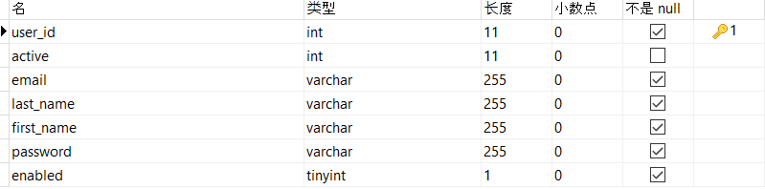

Note: user_id auto_increase.

role:



Note: role_id auto_increase.

user_role:



Note: user and role have many to many relationships.

verification_token:

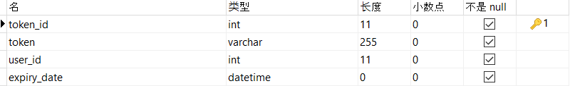

user’s validation info which would send to their registration email.

Front page design (like this):

1. Login page:

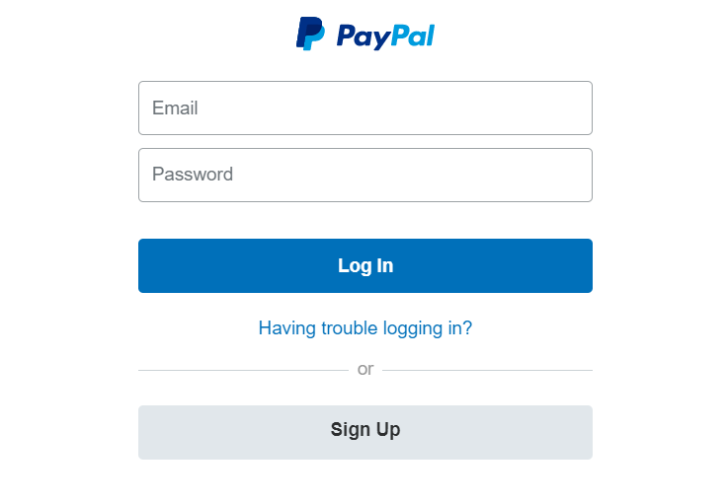

1. Registration page:

